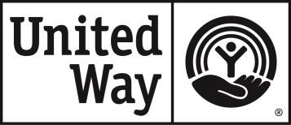
United Way of Rockingham County
301 Cherokee Camp Rd
Reidsville NC 27320

2026 ANTI-TERRORISM
COMPLIANCE CERTIFICATION

To comply with the USA Patriot Act and other counter-terrorism laws, the United Way of Rockingham County requires that all agencies receiving funds from our organization certify the following:

“I hereby certify that all United Way funds and donations will be used in compliance with all applicable anti-terrorist financing and asset control laws, statutes and executive orders.”

Agency Name: ___________________________________________________

Agency Address: ___________________________________________________

___________________________________________________

Agency Phone: ___________________________________________________

Name of Individual Making Certification: ________________________________

Signature: __________________________________________________________

Title: ___________________________ Date: ______________________________

PLEASE SIGN AND RETURN TO UNITED WAY OF ROCKINGHAM COUNTY

