Proceeds from this tournament will help fund the UWRC’s mission to support our partnering agencies with their efforts to improve our local community for all those who live in Rockingham County. The programs and services we help to fund must display sustainable outcomes which improve the lives of Rockingham County citizens.

 Each program or service must one of three goal areas: Education, Health & Safety, or Financial Stability. It is through this focus UWRC works to have a sustaining impact for all.



Thank you to UNC Rockingham Health Care for providing the PHYSICAL THERAPY TRIAGE TENT. Therapists from the Eden hospital will be providing education and triage on the management of sports injuries, including the latest taping techniques to help you get through your game! Stop by and meet the Sports Therapy Team form UNC Rockingham Health Care.



Thank you to Cirrus Construction, Inc. for being our Awards Sponsor and your continued support for non-profits in Rockingham County.

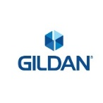

Thank you to Gildan of Eden for your continued support of the United Way of Rockingham County and our entire Rockingham County Community!

cid:image001.png@01D4D020.49D14790

Thank you to Bridgestone Aircraft Tire (USA), Inc for the Court Level Sponsorship.

**Ball Level Sponsors**

 

***Partnering Agencies***

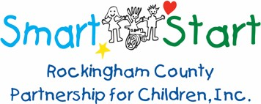 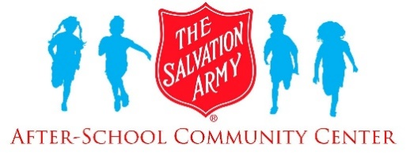  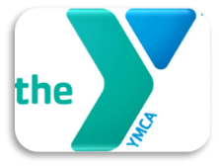 



 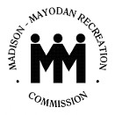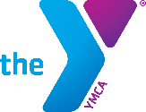

*Reidsville Rescue*

*Squad*

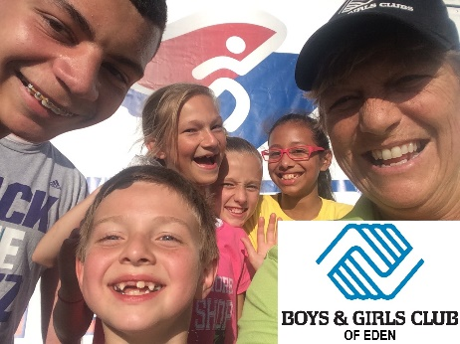

**United Way of Rockingham County** partners with 17 non-profit agencies across Rockingham County to assist in funding 31 different programs and services for our community. The United Way of Rockingham County (UWRC) is how our community comes together to assist our neighbors in meeting needs and problem solving. “Local people, raising Local dollars, to meet Local needs”.

**

**2nd Annual**

UWRC

*Fast* **4**

**Tennis Tournament**

# April 18, 2020



**Eden Family**

**YMCA**

**301 S Kennedy St**

**Eden, NC**

United Way of Rockingham

County Fast 4 Tennis

Tournament

Fast 4 Tennis is a shortened format of tennis for ages 16+.

RULES & REGULATIONS

* Each player must register separately notating the Partner’s name at the bottom of their registration
* Players must register for each event separately (can be done on one form, but $25 fee applies for both events)
* Scoring: Scoring will remain 15, 30, 40, game. First to 4 games wins the set.
* No-AD scoring: At deuce (40-40), the winner of the next point wins the game. The receiver chooses which side the point is played.
* Tiebreaker at 3 games all:

FAST 4 Tiebreaker

* First to 5 points, win by 1

* 2 points serving each (starting deuce side)

* Change ends once only after 4 points

EXAMPLE:

* Player A – 2pts serving
* Player B – 2pts serving
* Change ends
* Player C – 2pts serving
* Player D – 2pts serving
* If a tiebreaker reaches 4-4, the next point wins. Players come to the net and spin a racquet to determine server or side preference (same as prior to start of a match).

**Event Details:**

◻Registration begins at 8:00 AM

Registration fee is $25 per section per

player

Section Match Schedule

Women’s Doubles to begin at 9:00 AM

Mixed Doubles to begin at 1:00 PM

Men’s Doubles to begin at 5:00 PM

◻Lunch served from 11:00 AM—1:00 PM

◻Participants should check in at the registration tent 30 mins prior to the start of their section

**In the case of inclement weather, a RAIN date of June 1, 2019 has been scheduled.**

**Please make checks payable to:**

**United Way of**

**Rockingham County**

**Post Office Box 317**

**Wentworth, NC 27375**

For additional tournament information call The UWRC Office at

(336) 342-7768 or via email at

[casey@uwrockingham.org](mailto:casey@uwrockingham.org)

**UWRC Benefit Tennis Tournament**

**Saturday, April 18, 2020**

Please complete, detach and return this form with your check by April 11, 2020.

I plan to play in the tournament! My check is enclosed. (Please circle section below)

Women’s Doubles Mixed Doubles Men’s Doubles

I will be unable to play, but enclosed is a gift to support the United Way of Rockingham County.

Please make checks payable to the

### United Way of Rockingham County.

Name

Address

City State Zip

Phone Number (to contact you on tournament day in case of rain.)

Email Address

Skill Level (Please circle): ____________

Beginner Intermediate Advanced

T-Shirt Size (Please circle): M, L, XL, XXL

Partners Name:

Partners Phone: