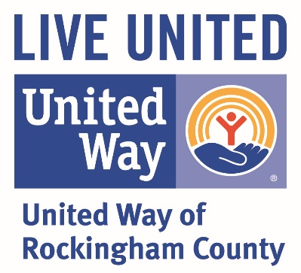

Campaign Handbook
2018-2019

Objective: Implement and evaluate an inclusive campaign plan, strategy and timeline to maximize resources and cultivate new markets.

- Become fully knowledgeable about the United Way of Rockingham County; its mission and goals, through attending meetings, visiting programs and services our organization supports, and reviewing materials and past campaign results.

- Recruit local community leaders to serve as members of the Campaign Cabinet and assist with the development and implementation of campaign strategies.

- Call on Chief Executive Offers and members of senior management to ask for their support. Effective corporate involvement is critical to a successful campaign.
- Make an effective case for the United Way.
- Update the CEO on the status, accomplishments and goals of our United Way and its’ campaign.
- Address any questions or concerns.
- Thank the CEO and the company for its past support.
- Review the company’s past support including corporate gifts and employee campaign totals (also any awards they may have won).
- Gain support for the campaign through the corporate gift and agreement to conduct another employee campaign.
- Ask the CEO to establish, promote, support and endorse a challenging goal for the employee campaign. Ensure the CEO appoints an enthusiastic, well-known and well-respected employee to lead the employee campaign effort.

